

Optimization of M/M/3 Queue System for Minimal Service Rate and Maximal Arrival Rate
By MADHAV SAI ARYAN KOTHAREDDY
20000705-T576

Table of Contents
1.Introduction 2
2. Methodology 2
2.1. Defining the Queueing Model (M/M/3) 2
2.2. Key Parameters 2
2.3. Computing the Probability of Exceeding Queue Size k 2
3 Observations: 3
3.1 Tabulated results 3
3.2. Plotted Results 7
4. Discussion 7
4.1. Comparison of Results for Different Queue Sizes 7
4.2. System Performance Interpretation 8
4.3. Implications and Recommendations 8
5. Conclusion 8

1.Introduction
In this project we performed simulation on a 3 server based M/M/3 queuing system the simulation was performed in MATLAB in this system there exists 3 service desks to serve customers the customer arrival is random and follows a passion distribution (λ) and serving time follows exponential distribution with rate (μ) . The primary goal is to study the probability of exceeding certain queue size thresholds for different arrival rates.
The analysis focuses on how the system behaves under varying traffic intensities and provides insights into the queuing model’s performance under different loads.

2. Methodology

2.1. Defining the Queueing Model (M/M/3)
The queuing model used is an M/M/3 system:
- M/M: Markovian arrivals and service times (Poisson arrival process and exponential service times).
- c = 3: The number of parallel service desks (servers).

2.2. Key Parameters
- Arrival Rate λ: Varying from 0 to 1, which controls the number of customers arriving per unit of time.
- Service Rate μ=1: Fixed at 1 customer per unit of time for each service desk.
- Queue Size Threshold k: Thresholds were set at 10, 100, and 1000 customers to investigate how often these thresholds are exceeded.
- Utilization ρ=λ/cμ: Measures the system's load. A utilization factor close to 1 indicates the system is heavily loaded.

2.3. Computing the Probability of Exceeding Queue Size k
To compute the probability of exceeding a queue size k, the following steps were taken:
- Steady-State Probability Calculations: Based on queue theory, the steady-state probabilities were calculated to determine how likely it is that the system exceeds certain queue lengths.
- Varying λ: The arrival rate λ was varied between 0 and 1 to observe how the system behaves under different loads.
- Simulation for Large Queue Sizes: The probabilities were calculated for k = 10, 100,k=10,100, and 1000 to explore the system's performance as the queue size increases.

3 Observations:

3.1 Tabulated results
Optimization Results (Minimal Service Rate for Various Arrival Rates):
Arrival Rate (Lambda) Minimal Service Rate (Mu)
0.10 1.03
0.20 1.07
0.50 1.17
1.00 1.33
Optimization Results (Maximal Arrival Rate for Various Service Rates):
Service Rate (Mu) Maximal Arrival Rate (Lambda)
0.10 0.19
0.20 0.38
0.50 0.95
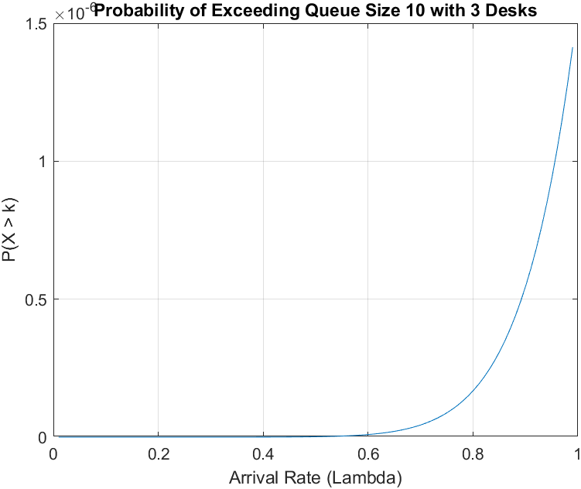
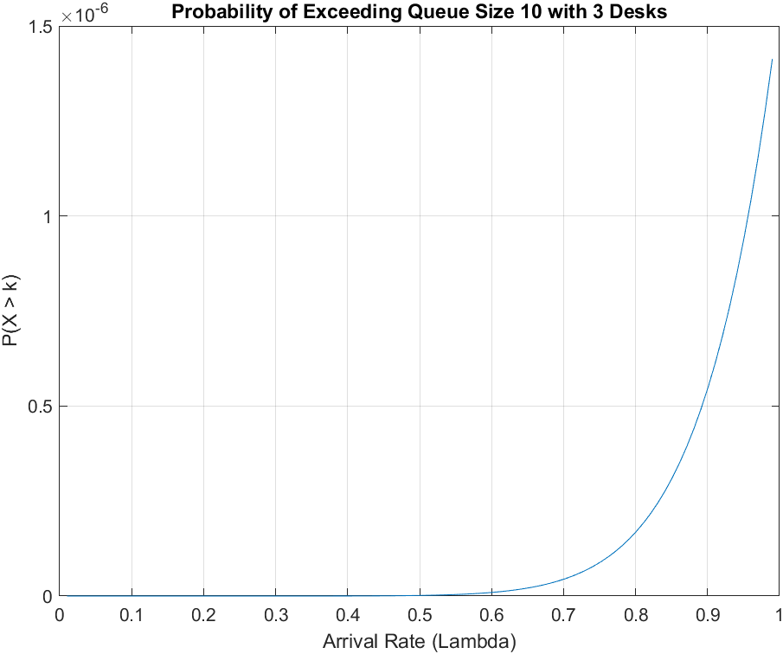
1.00 1.91

Optimization Results (Minimal Service Rate for Various Arrival Rates):
Arrival Rate (Lambda) Minimal Service Rate (Mu)
0.10 1.03
0.20 1.07
0.50 1.17
1.00 1.33
Optimization Results (Maximal Arrival Rate for Various Service Rates):
Service Rate (Mu) Maximal Arrival Rate (Lambda)
0.10 0.28
0.20 0.56
0.50 1.40
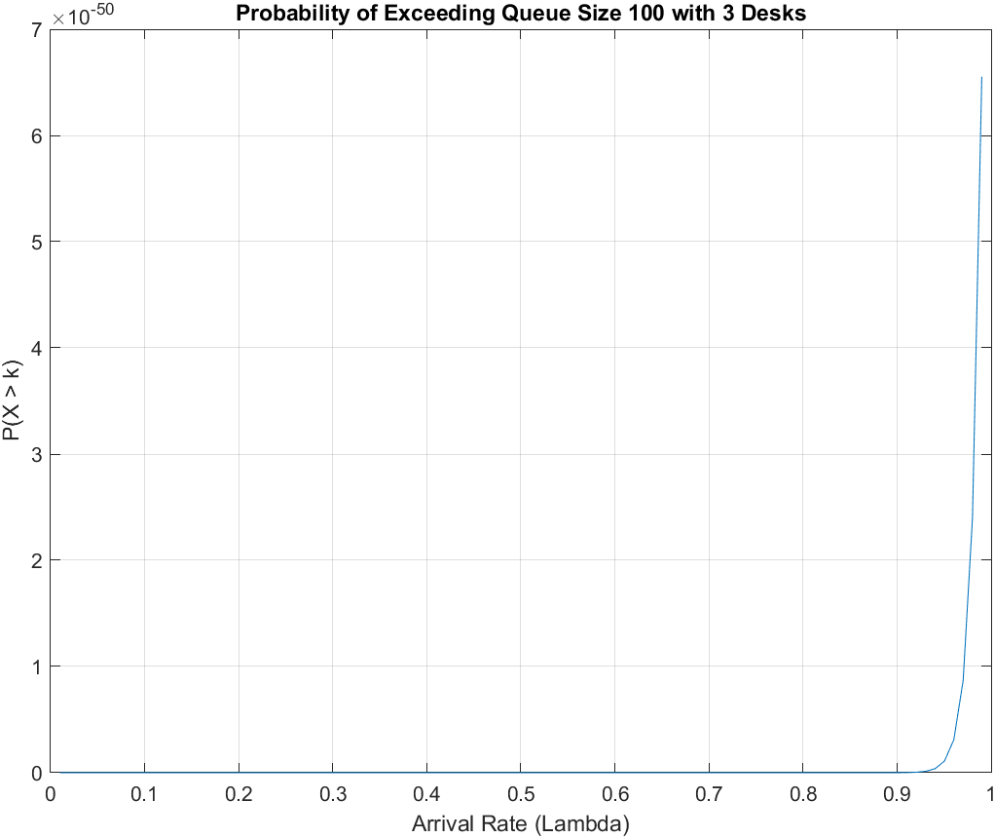
1.00 2.80

Optimization Results (Minimal Service Rate for Various Arrival Rates):
Arrival Rate (Lambda) Minimal Service Rate (Mu)
0.10 1.03
0.20 1.07
0.50 1.17
1.00 1.33
Optimization Results (Maximal Arrival Rate for Various Service Rates):
Service Rate (Mu) Maximal Arrival Rate (Lambda)
0.10 0.29
0.20 0.59
0.50 1.48
1.00 2.97
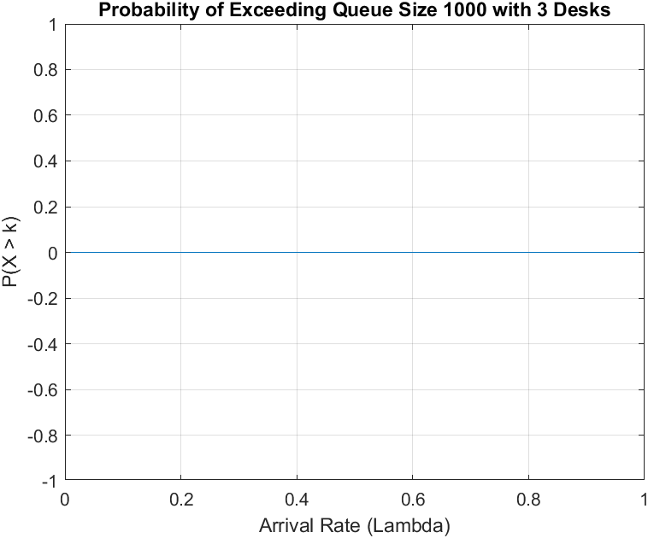

Optimization Results (Minimal Service Rate for Various Arrival Rates):
Arrival Rate (Lambda) Minimal Service Rate (Mu)
0.10 1.03
0.20 1.07
0.50 1.17
1.00 1.33
Optimization Results (Maximal Arrival Rate for Various Service Rates):
Service Rate (Mu) Maximal Arrival Rate (Lambda)
0.10 0.29
0.20 0.59
0.50 1.47
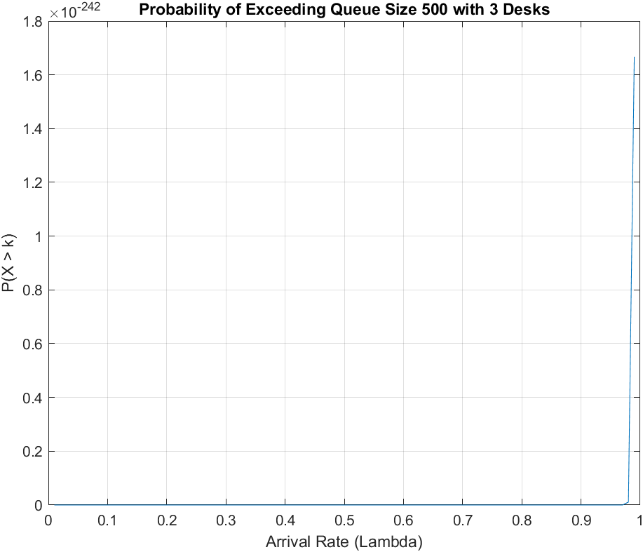
1.00 2.95

3.2. Plotted Results

3.2.1. Probability of Exceeding Queue Size 10
Observation:
- The probability remains near 0 for low arrival rates.
- As λ approaches 1, the probability increases sharply, reaching around 10−6.

3.2.2. Probability of Exceeding Queue Size 100
Observation:
- The probability of exceeding a queue size of 100 is significantly smaller than for 10.
- For most arrival rates, the probability is negligible (in the order of 10−50), but it rises as λ approaches 1.

3.2.3. Probability of Exceeding Queue Size 1000
Observation:
- The probability of exceeding 1000 customers is effectively zero for all values of λ.
- The system is highly unlikely to see such large queue sizes, even under the heaviest loads.

4. Discussion

4.1. Comparison of Results for Different Queue Sizes
The computed probabilities for exceeding different queue sizes reveal the system's ability to handle traffic at different loads. The analysis shows that:
- For Small Queue Size Thresholds (e.g., 10):
The probability increases rapidly as the arrival rate approaches the service rate. This implies that the system begins to struggle when it is near full utilization (ρ≈1). Even with only 3 service desks, small queues form when arrival rates exceed 0.8.
- For Medium Queue Size Thresholds (e.g., 100):
The system's capacity to prevent long queues is robust. The probability of exceeding a queue size of 100 remains exceptionally low for most arrival rates, only becoming non-zero at very high values of λ. This suggests that the system can comfortably handle moderate customer traffic without the risk of large queues forming.
- For Large Queue Size Thresholds (e.g., 1000):
The probability is effectively zero for all arrival rates considered. This demonstrates that the system can handle a large volume of customers efficiently, without leading to excessively long queues. In practical terms, a queue size of 1000 is unlikely to ever be reached, even under the heaviest loads.

4.2. System Performance Interpretation
- Effective System Performance Under Normal Loads:
The results show that for moderate arrival rates (up to 0.8), the system performs well, with little to no probability of large queues forming. The service desks are able to handle the incoming traffic without significant queue buildup.
- System Strain at High Arrival Rates:
As the arrival rate approaches 1 (or when the utilization ρ approaches 1), the system begins to exhibit signs of strain, as reflected in the increasing probability of exceeding small queue sizes (e.g., 10). This suggests that the system's performance degrades under heavy traffic conditions, and additional service desks may be required to maintain smooth operations.

4.3. Implications and Recommendations
Based on the results:
- Monitor Arrival Rates: It's critical to monitor the arrival rate λ closely, especially when it begins to approach the service rate μ. As utilization increases, so does the risk of longer queues.
- Consider System Expansion: To prevent the formation of long queues under heavy loads, it may be necessary to add additional service desks (increase ccc) or improve service rates. This will reduce the probability of exceeding small queue thresholds, even when λ is high

5. Conclusion
This project analysed an M/M/3 queuing system under varying traffic loads. The results show that the system performs well under moderate loads, with minimal risk of long queues. However, as arrival rates approach the system's capacity, the likelihood of long queues increases. The analysis suggests that for very large queue thresholds, the system is stable and can handle high traffic loads effectively.

